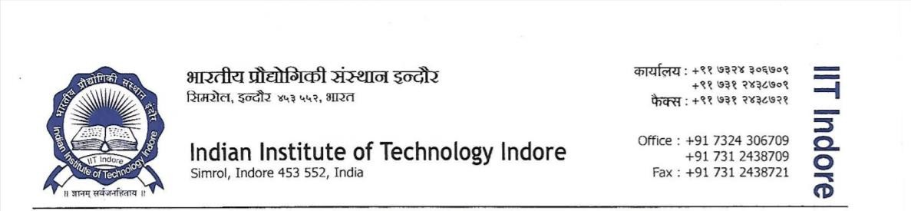

Application for Senior Research Fellow (SRF) position in the Department of Mechanical Engineering
Project Supported by DST Technology Development board
Applications are invited from highly motivated candidates for a SRF position in the field of “Laser based micro 3d printing and shape memory alloy device development”.

Eligibility

- First class in B.E/B.Tech/M.E/M.Tech/P.Hd. in Mechanical/ Manufacturing/ Metallurgy Engineering and Material science/Mechatronics/Electronics and Instrumentation/ Instrumentation and Control and other relevant areas. With GATE qualification and one years of research experience.

Fellowship details:
Senior research fellow will be paid a Fellowship of 42,000 +18% HRA.

Service conditions:

- DA will not be entitled for SRF
- Othe rules are as per institute norms.
Duration: The appointment is initially for one years and it will be extended based on the performance. Kindly submit your resume with relevant documents to Prof. Palani through email: palaniia@iiti.ac.in with a subject “Senior Research Fellow under DST TDP Project”. The Last date for submitting the application is 27th March 2026.

